Information Management Region 9

**BCS Modeling Quick Guide (Draft)**

**Background**

This process uses both ArcMAP 10.8.2 and ArcGIS Pro to extract and buffer data. You must have an active AMT role to use ArcMap and access NRM data via the Geospatial Interface (GI). Data will be extracted from the GI and saved to a file geodatabase. You will then need to open ArcGIS Pro to use the BCS Script tool to create buffers. Efforts are being made to establish a solution for extracting NRM Wildlife data without the GI and modeling exclusively in ArcGIS Pro.

The script tool for applying buffers look for specific data entries. Your unit Wildlife Data Steward assisted by GIS Staff should ensure that all bat data is entered into NRM Wildlife using the NRM Wildlife data templates (provided).

**Tool summary**

The BCS NRM Data Buffering tool was developed to support BCS buffer modeling at the unit level using the existing NRM Wildlife application data. The tool follows the established rulesets set forth in the BCS which are provided [here](https://usdagcc.sharepoint.com/:b:/r/sites/fs-r09-fbcc/Shared%20Documents/BCS%20GIS%20Products%20and%20Templates/GIS%20Rulesets/BCSBufferingRulesetsFinal.pdf?csf=1&web=1&e=0JoClG). This tool uses existing attributes to filter data for buffering which requires specific entries to be made. Data entry templates are provided to ensure the required fields are populated with data that is neccesary for modeling buffers. A brief summary of the buffering tool is as follows:

Add tool summary here.

**Project Setup**

* Open ArcGIS Pro Template – Navigate to the URL path listed below and open the ArcGIS Pro Template titled “BCSDataBuffering”.
  + T:\FS\Reference\GeoTool\r09\ProTemplates\BCSTemplates\BCSBuffering
  + Select unpacking location (Where you want the project to be located)
* Save and open project – When prompted name your project and save it to prefered location (i.e. workspace in program folder). Ensure your path to save is the same as your unpacking location set above.
* Note location project FGDB – Open the catalog pane, expand “Databases”, and note the name/location of the project file geodatabase.
  + Example:

* Open ArcMap and Extract data from GI – Follow the instructions listed in the data extraction exercises to extract NRM Wildlife data from the GI in ArcMap.
* Be sure to export the GI Data to your poject FGDB location that was noted earlier.
* Close ArcMap and go back to your ArcGIS Pro project.
* Follow the tasks embedded in the Pro project along with this documentation to complete the buffering process.

**Capture Data GI Extraction**

* Log into the VDI, open ArcMAP, Open the GI, and select NRM Production server
* Navigate to Wildlife/Enterprise Data Warehouse (EDW)/Load - WL Base Map (EDW)

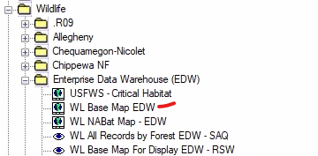

* 1. Select Region, Unit, Business Area = Wildlife (WL), and Taxa in Chiroptera (Bats), Myotis lucifugus (Little Brown Bat), Myotis sodalis (Indiana Bat), Myotis septentrionalis (Northern Long-eared Bat), perimyotis subflavus (Tri-colored Bat). Select ok.

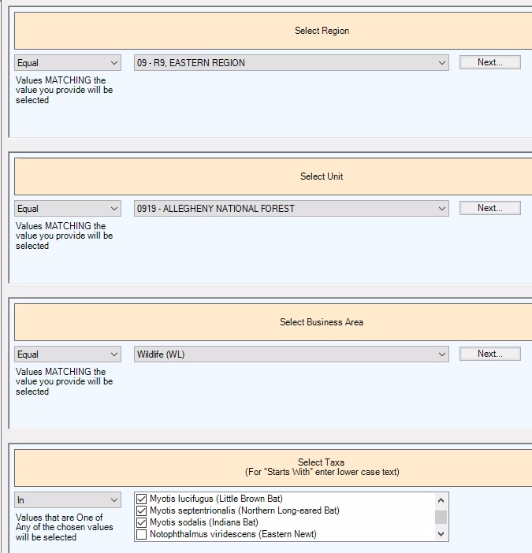

* 1. Select FishWildlife_Observation_EDW layer in TOC
     1. Open attribute table and select all records

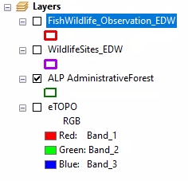

* 1. Hit the eyeball to select visualizations

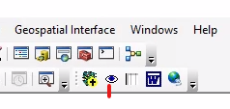

* 1. Under EDW select and load WL Observations with Individuals EDW – RSW

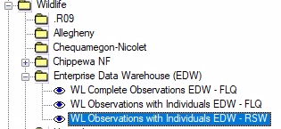

* 1. Select your unit, busines area = Wildlife, taxa level = species, taxa level = all, taxa = Myotis lucifugus (Little Brown Bat), Myotis sodalis (Indiana Bat), Myotis septentrionalis (Northern Long-eared Bat), perimyotis subflavus (Tri-colored Bat), calender year, observation year = any
  2. Export WLAqs_Observation_Pt to your project FGDB

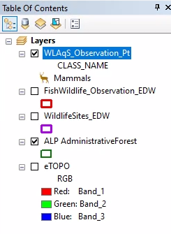

**Roost and Hibernacula Data GI Extraction**

* Log into the VDI, open ArcMAP, Open the GI, and select NRM Production server
* Navigate to Wildlife/Enterprise Data Warehouse (EDW)/Load - WL Base Map (EDW)



* 1. Select Region, Unit, Business Area = Wildlife (WL), and Taxa in (Chiroptera (Bats), Myotis lucifugus (Little Brown Bat), Myotis sodalis (Indiana Bat), Myotis septentrionalis (Northern Long-eared Bat), perimyotis subflavus (Tri-colored Bat). Select ok.



* 1. Select WildlifeSites_EDW layer in TOC
     1. Open attribute table and select all records

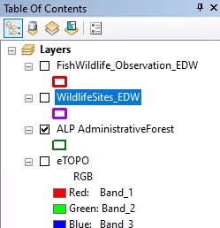

* 1. Hit the eyeball to select visualizations



* 1. Under EDW select and load WL Site Observations EDW – RSW

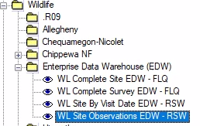

* 1. Select your unit, Site Taxa = Chiroptera, Site Category = Biological, Site Type = All, Site = All, Visit Start Date = (Local unit discretion, Use post wns if applicable), Visit Last Date = Leave as default
  2. Export WL_Site_Observation_Pt to your project FGDB

* Run the tool and view details as tool runs to observe process if desired.
* Outputs will be entered in the FGDB and table of contents pane. Note: if the tool did not filter any qualifying data a buffer layer output will not be created.
  + UnitRoostPTS = A feature class with the filtered qualifying points
  + All others will be the resulting buffers created for each species

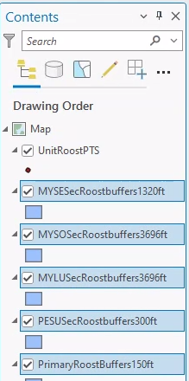

**Data Buffering**

**Appendix 1**



